OUTPUT Day_02

1) Alter Table:

* Add a new column linkedin_profile to employees table to store LinkedIn URLs as varchar.
* Change the linkedin_profile column data type from VARCHAR to TEXT.
* Add unique, not null constraint to linkedin_profile
* Drop column linkedin_profile

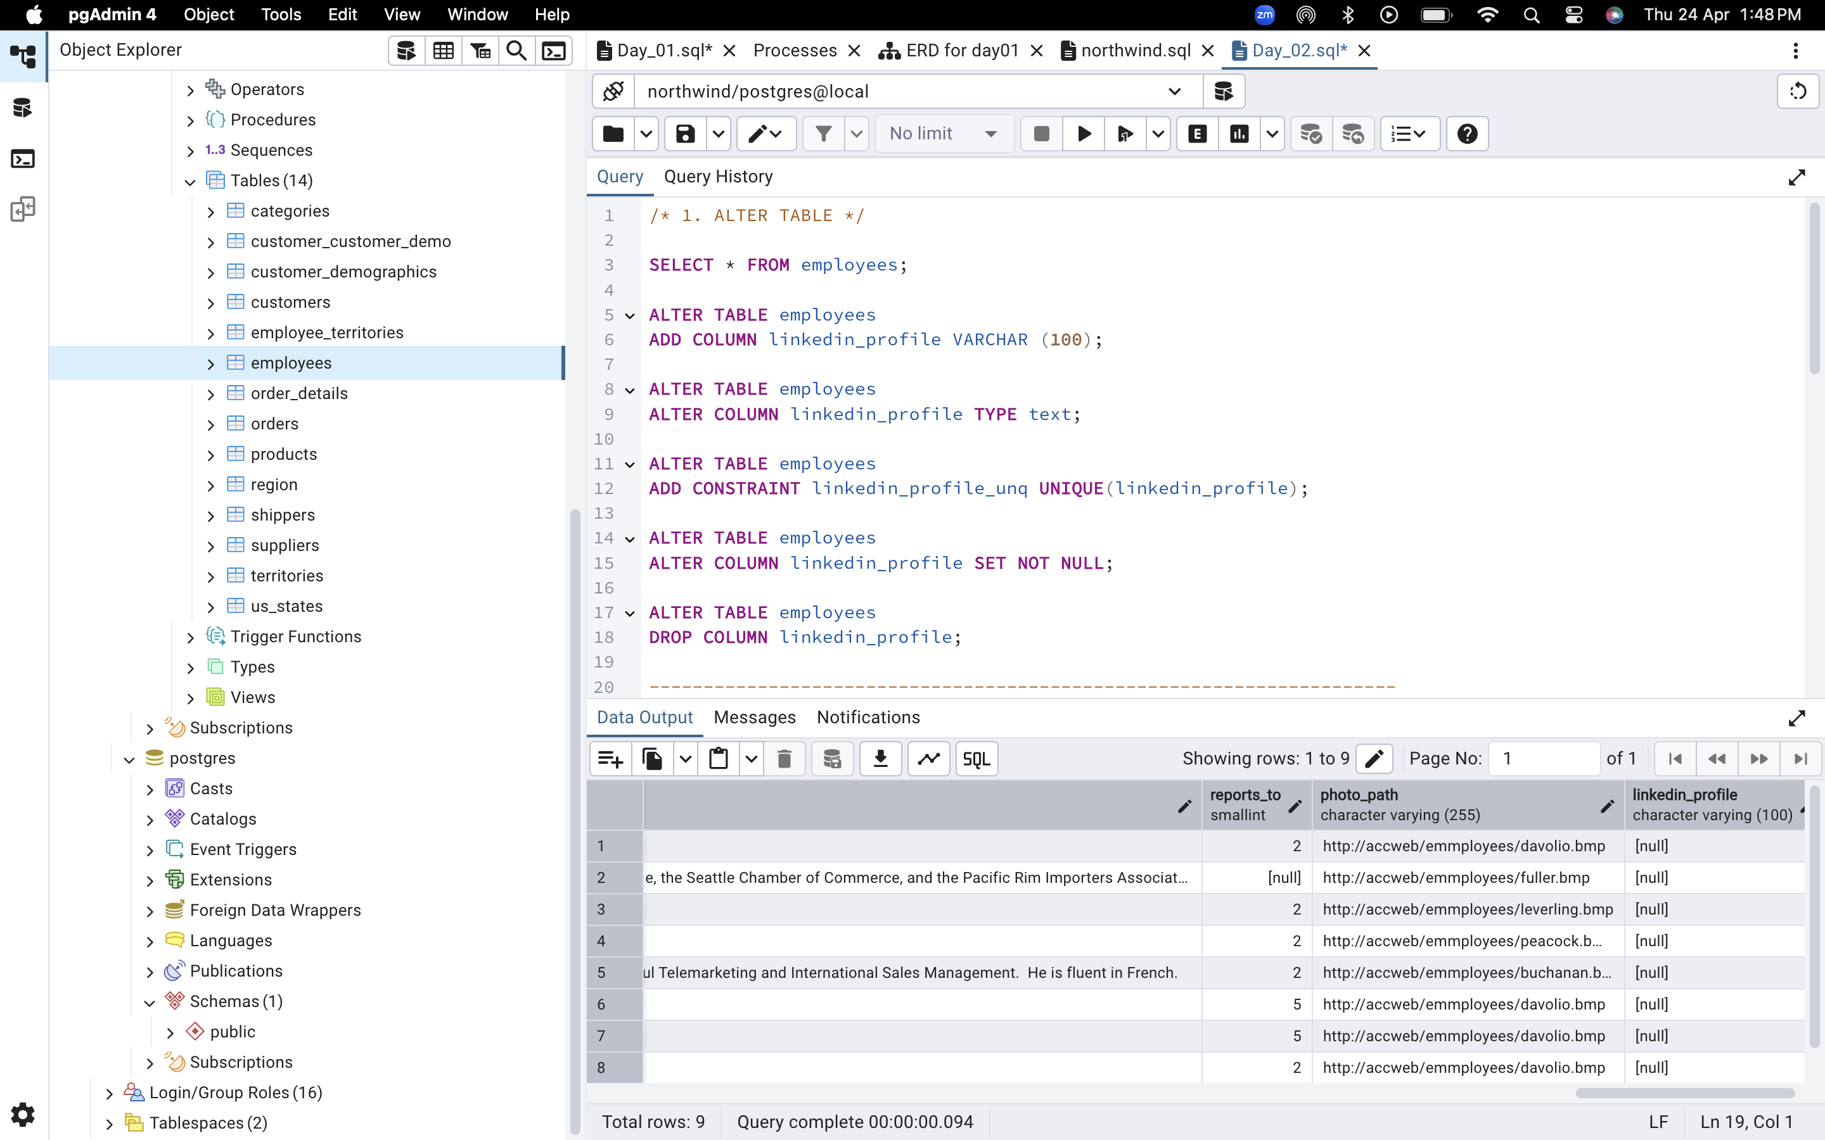

2) Querying (Select)

* Retrieve the employee name and title of all employees

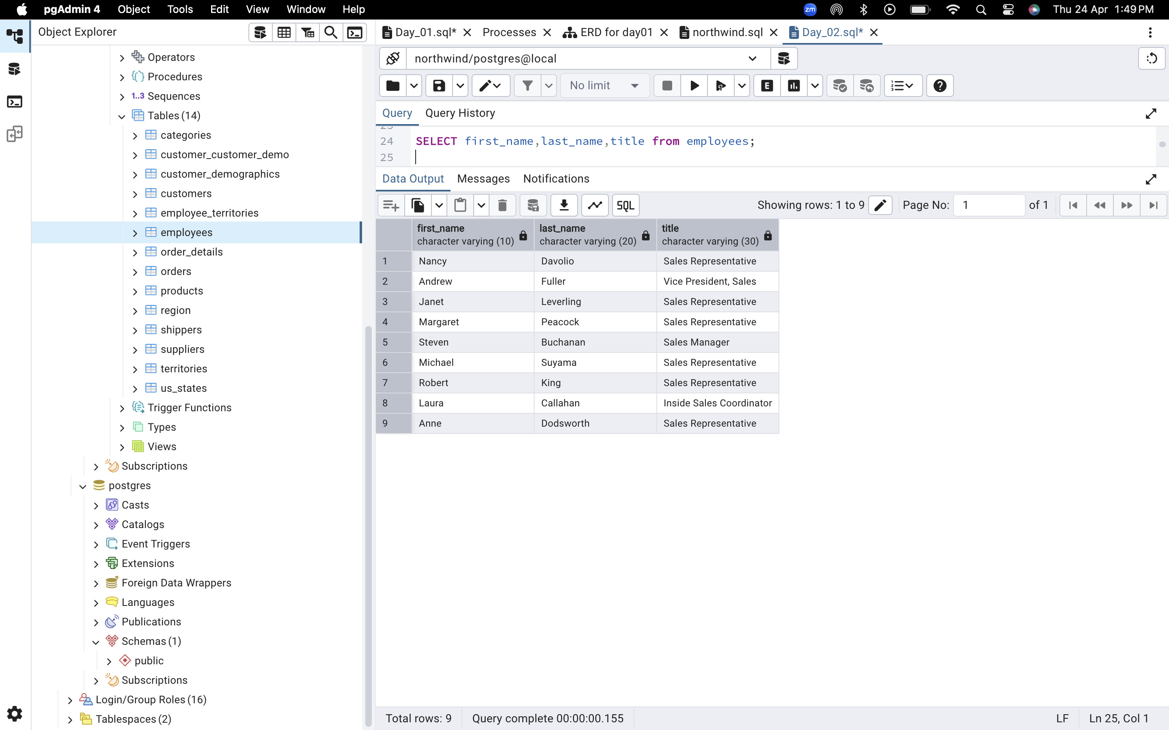



* Find all unique unit prices of products

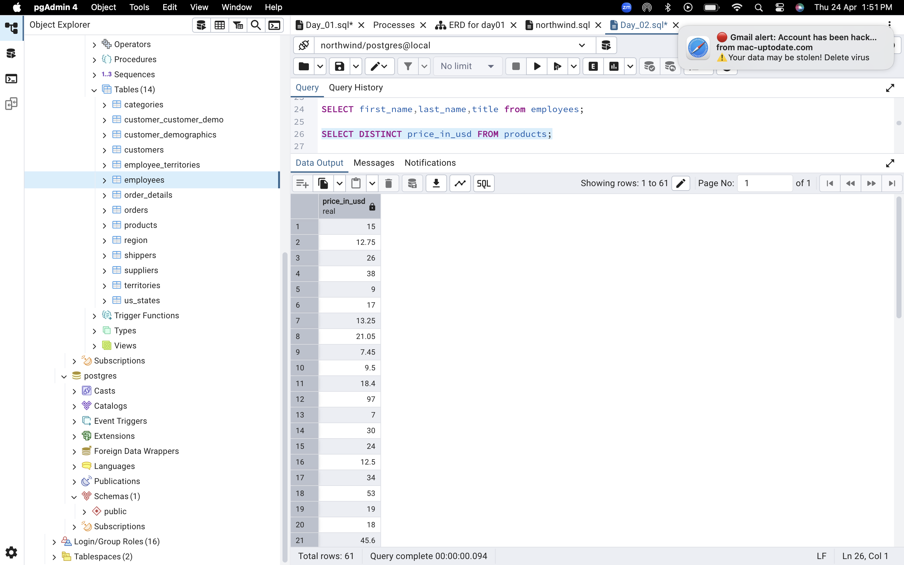

* List all customers sorted by company name in ascending order

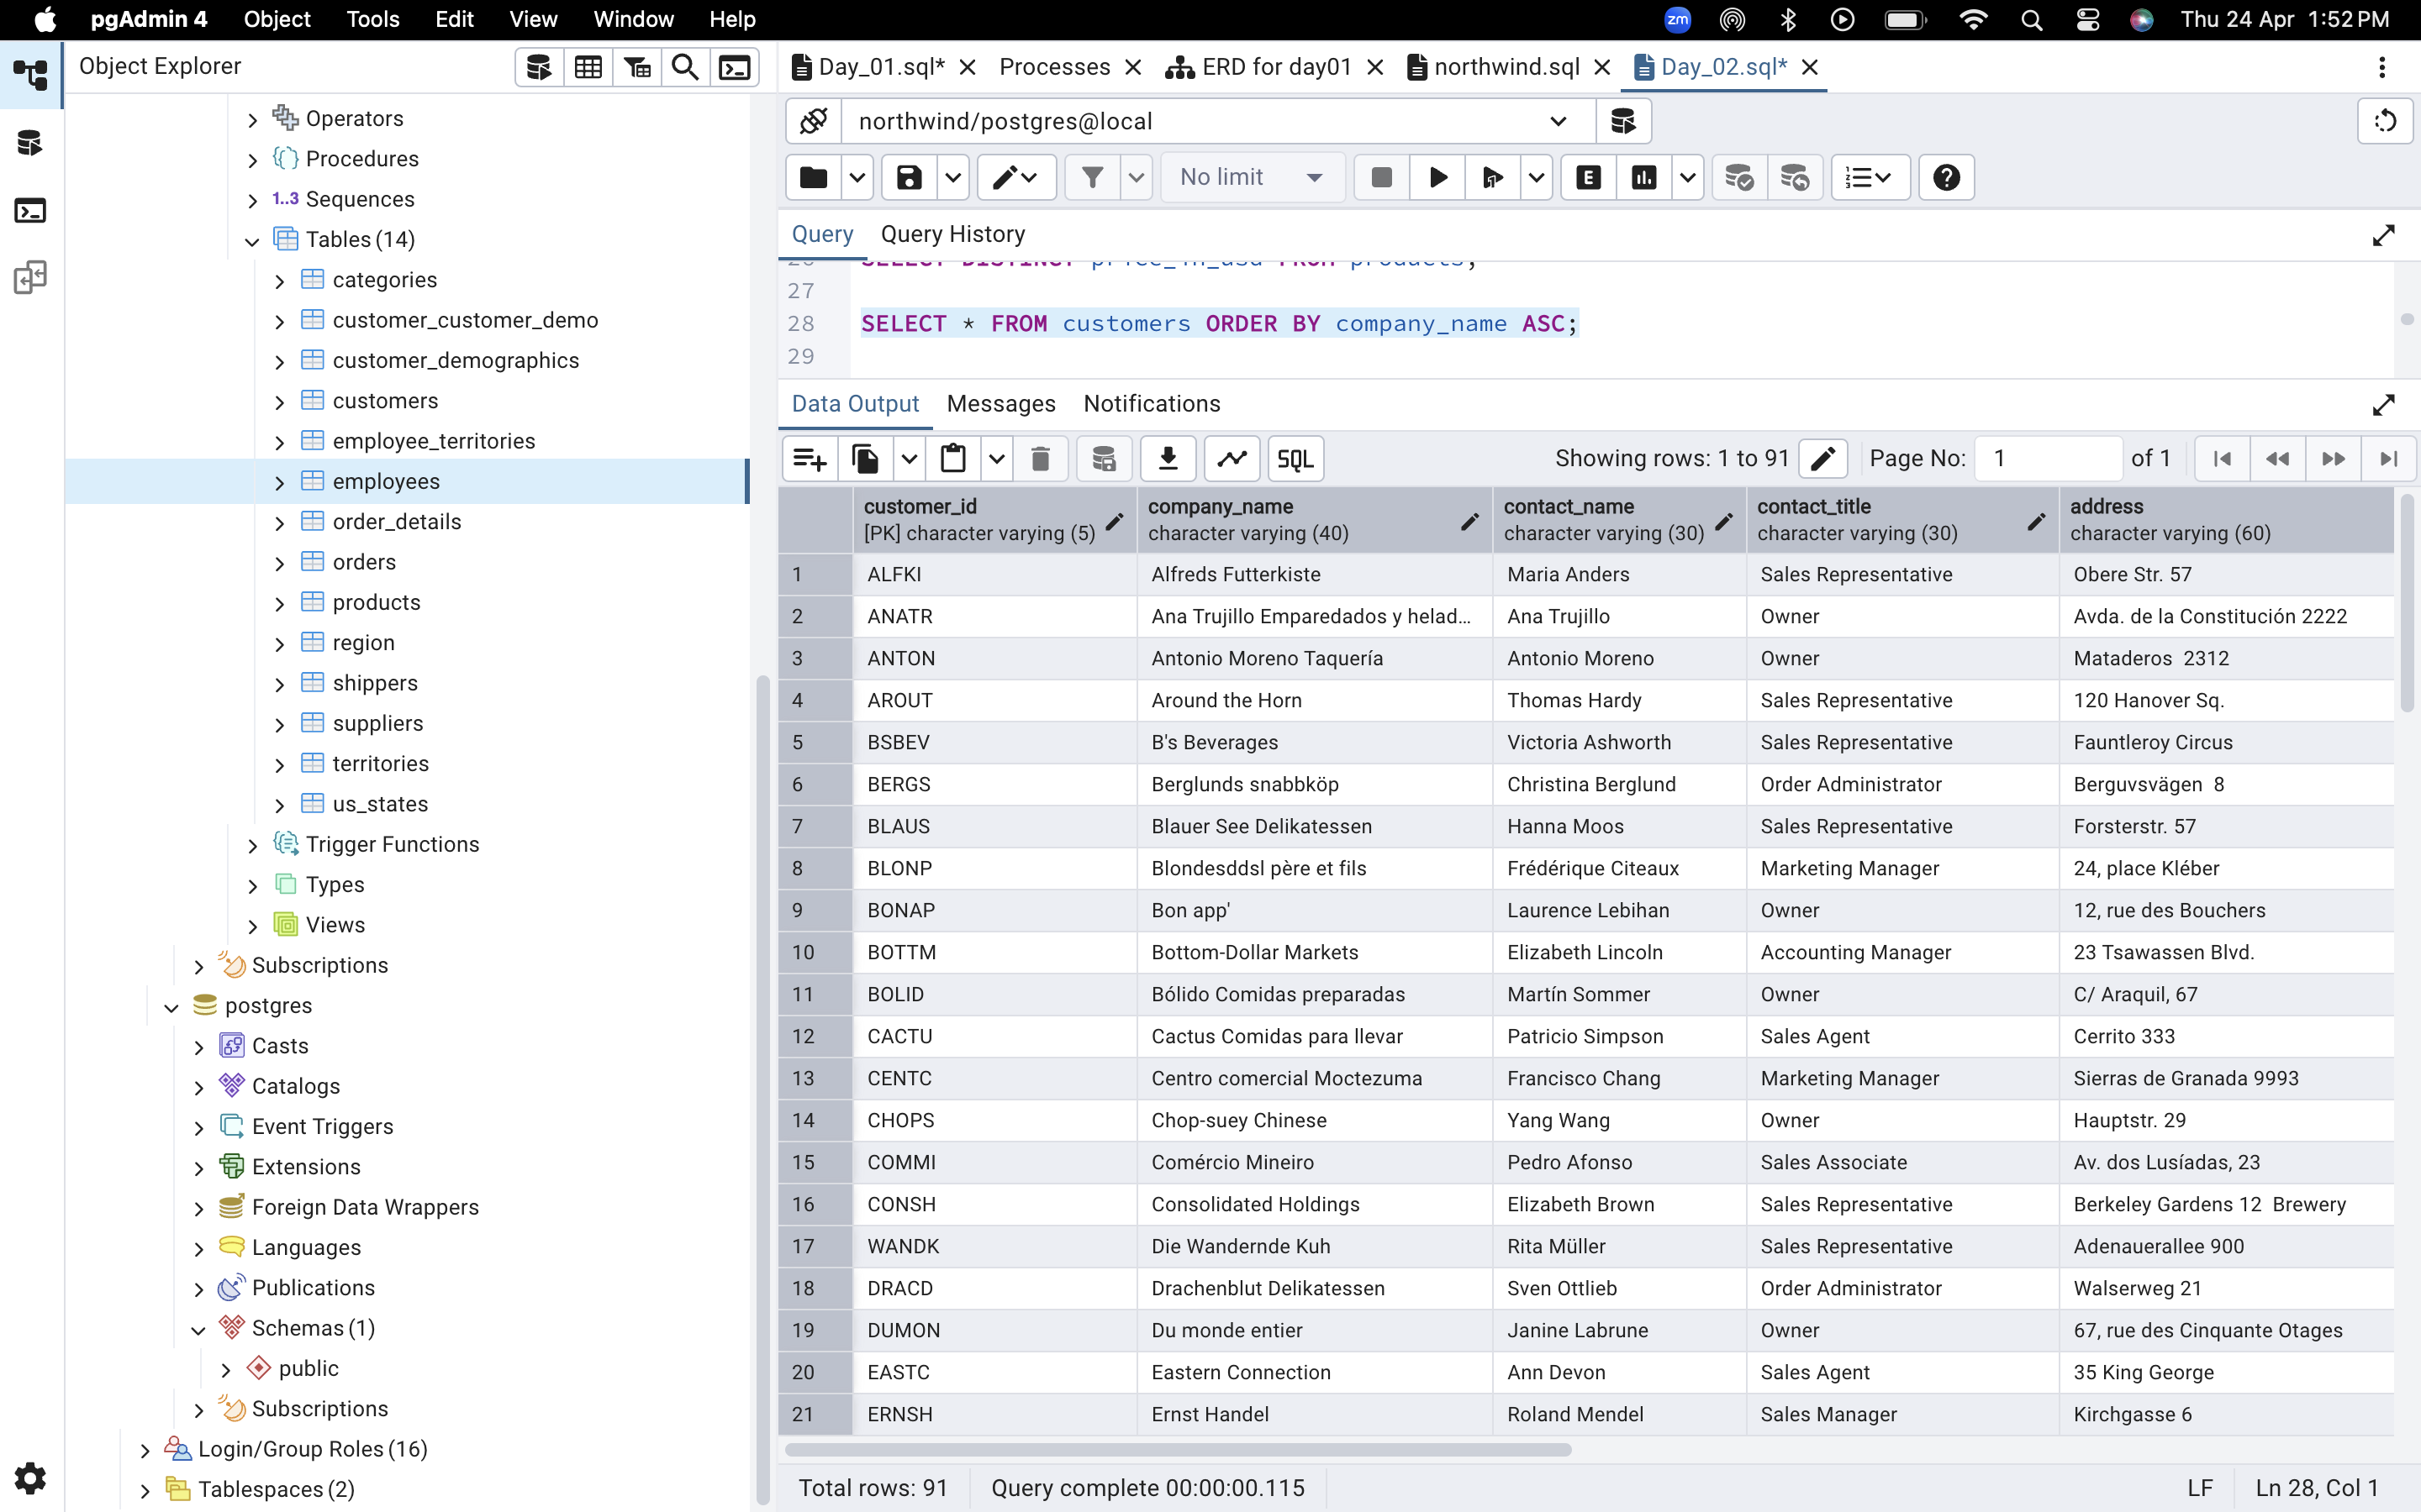

* Display product name and unit price, but rename the unit_price column as price_in_usd

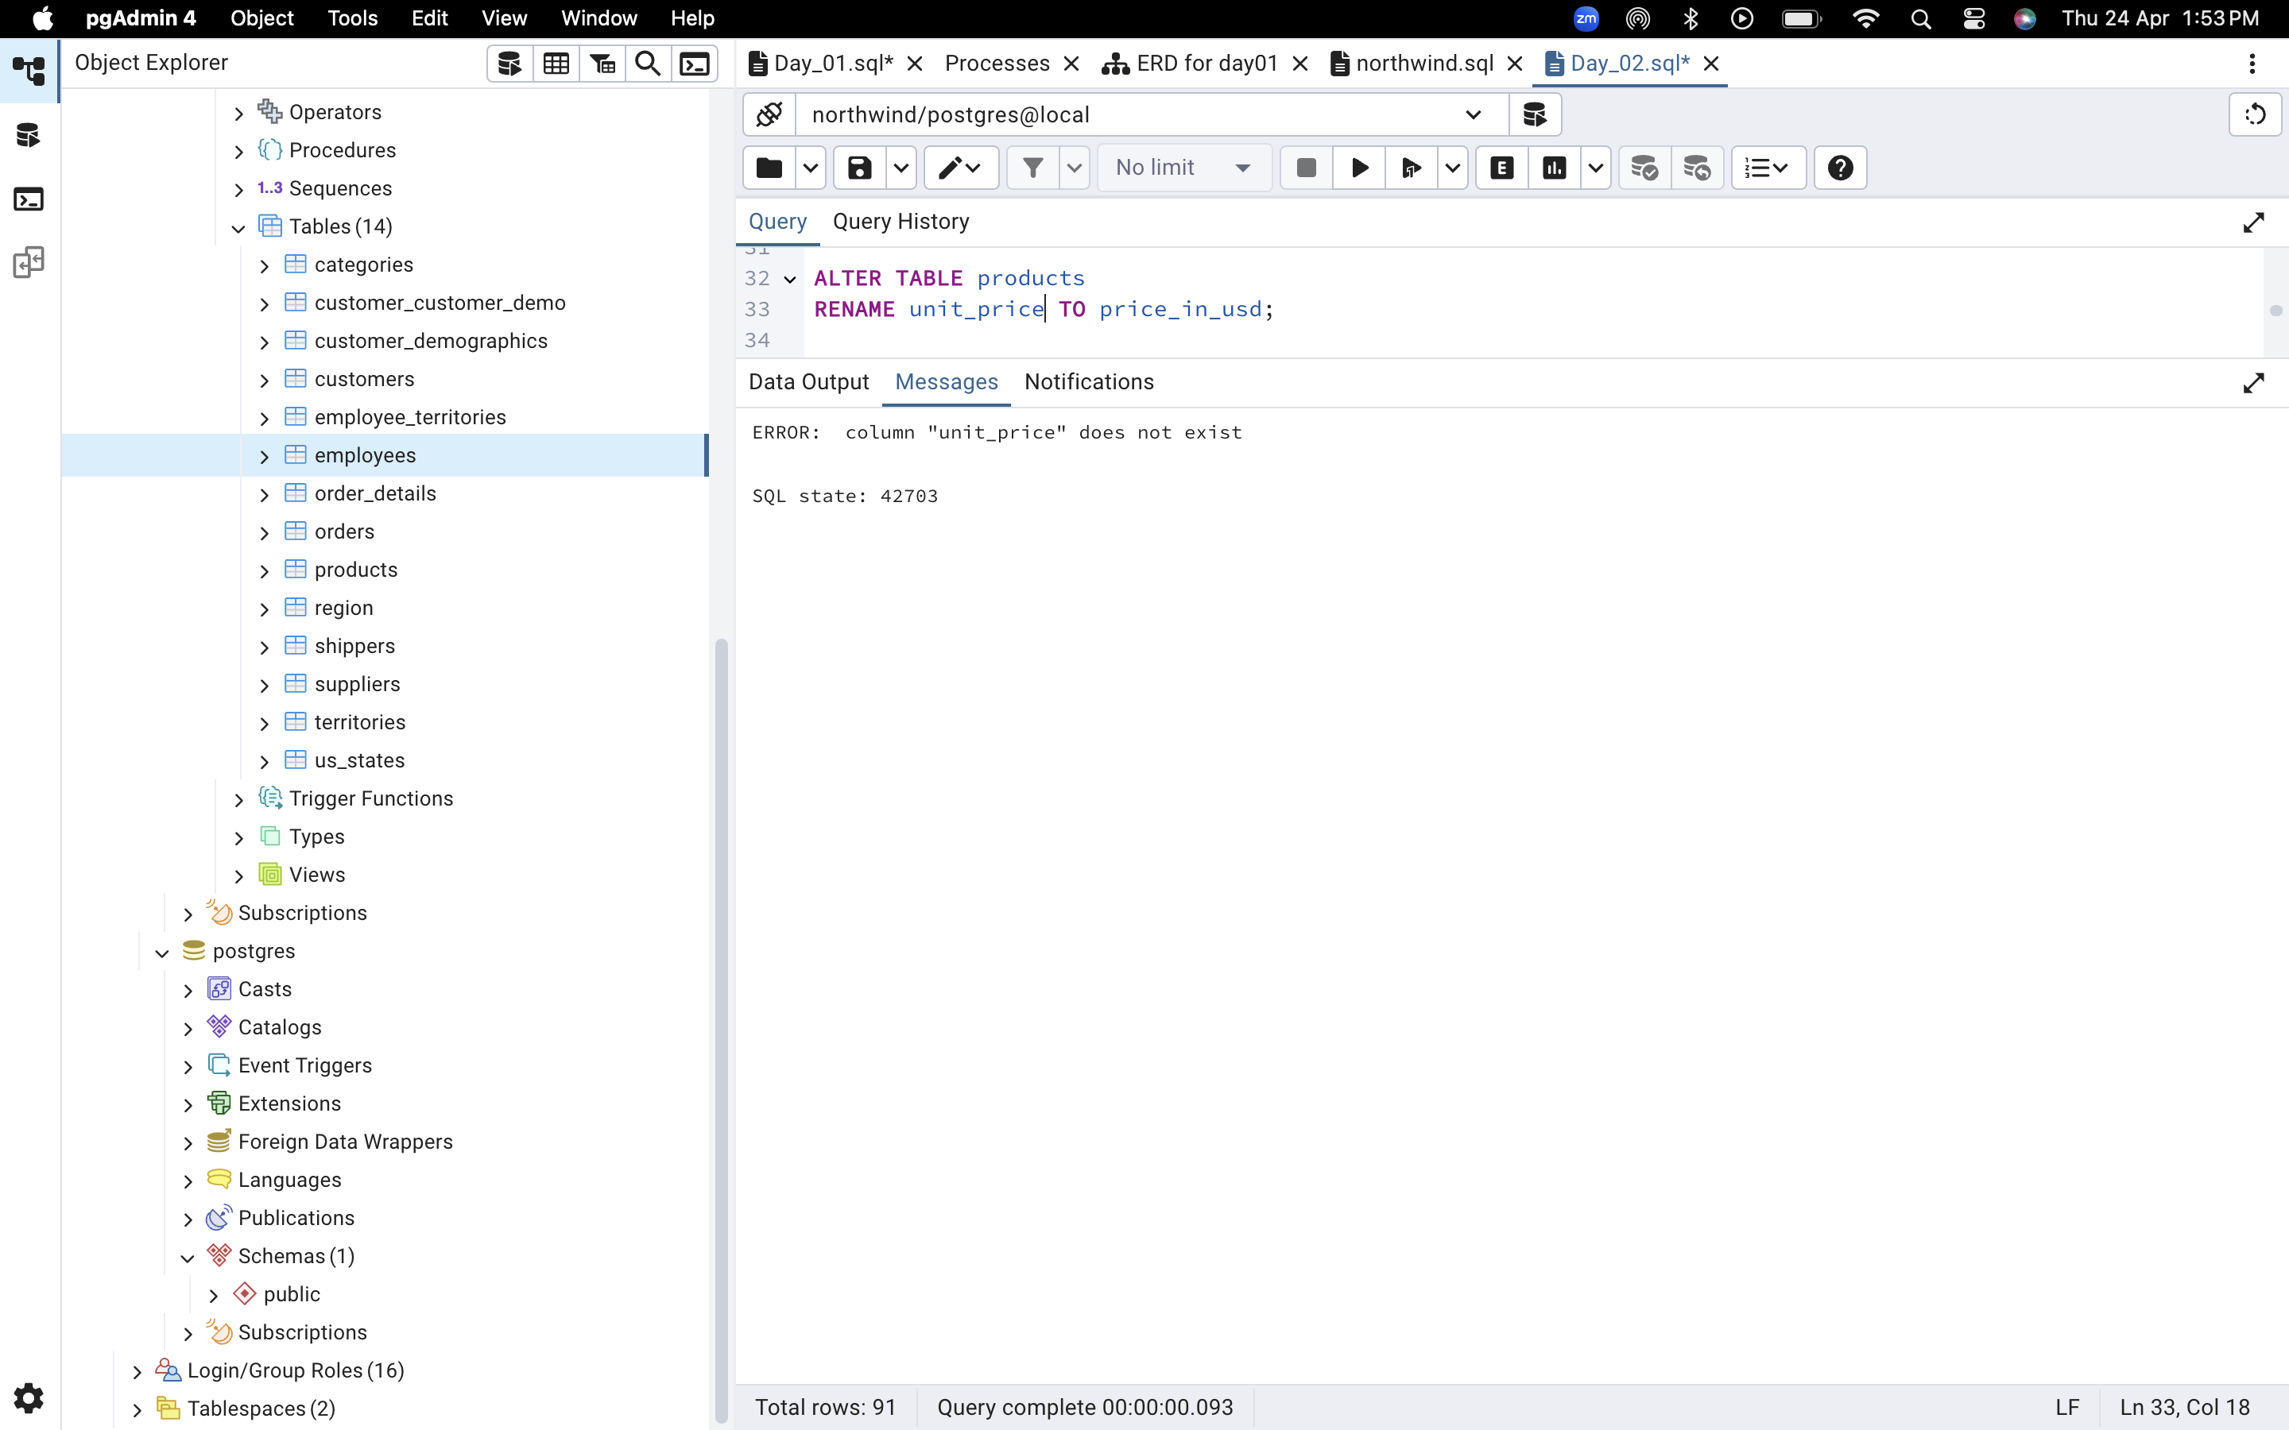

3) Filtering

* Get all customers from Germany.

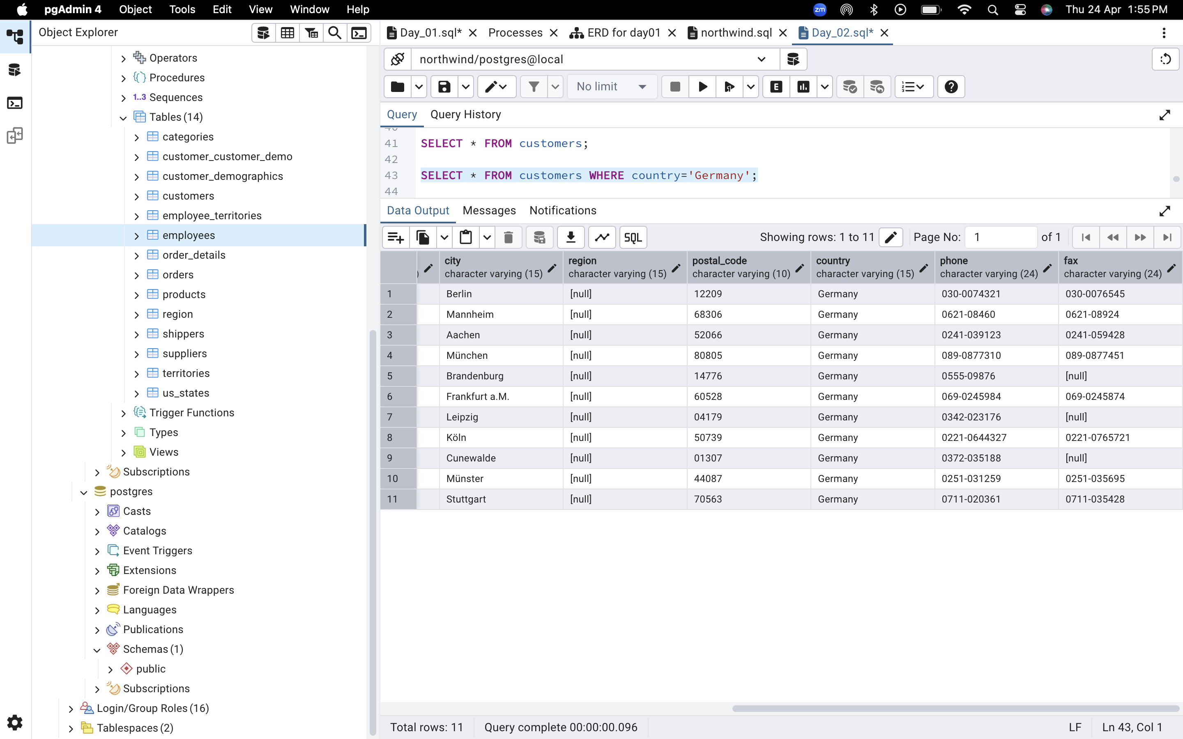

* Find all customers from France or Spain

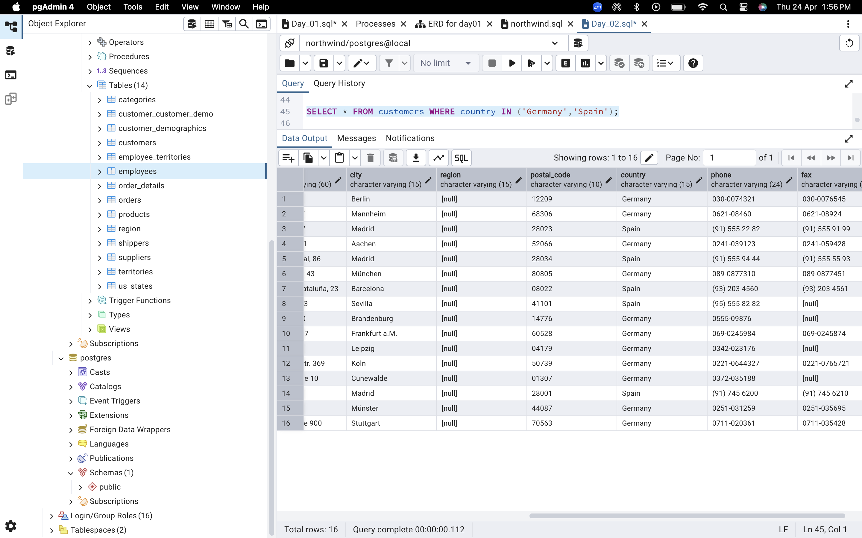

* Retrieve all orders placed in 2014(based on order_date), and either have freight greater than 50 or the shipped date available (i.e., non-NULL) (Hint: EXTRACT(YEAR FROM order_date))

